**TI BYTE Simulation Exercise**

**Week 0 : Voltage and Current Sources**

* **Question 1:**

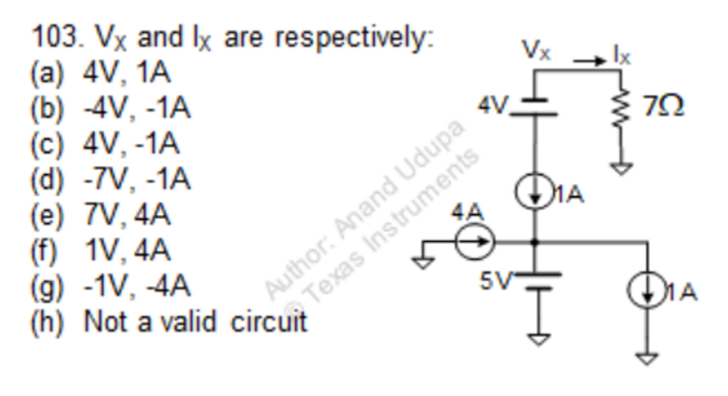

* **QUCS Circuit:**

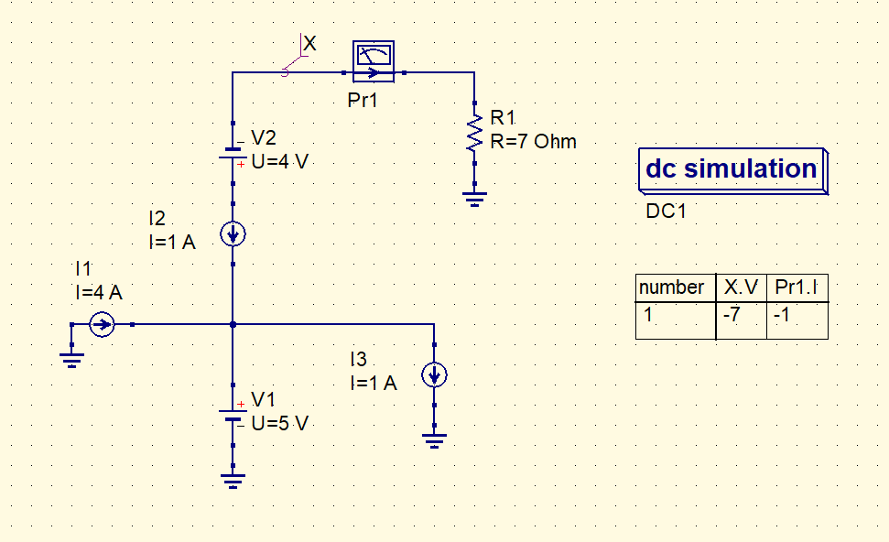

* **X is used to label the node and find the voltage at that node.**
* **Current probe (Pr1) is used to check the current through that wire.**
* **QUCS Result:**

**Therefore, from the simulation, we get our answer as:**

**Vx = -7V**

**I(Pr1) = -1A**

**Answer: (d)**

* **Conclusion:**
* **In a series circuit, the current that flowing through each component is the same.**
* **A voltage source and a current source in series is equivalent to a current source in series.**
* **Question 2:**

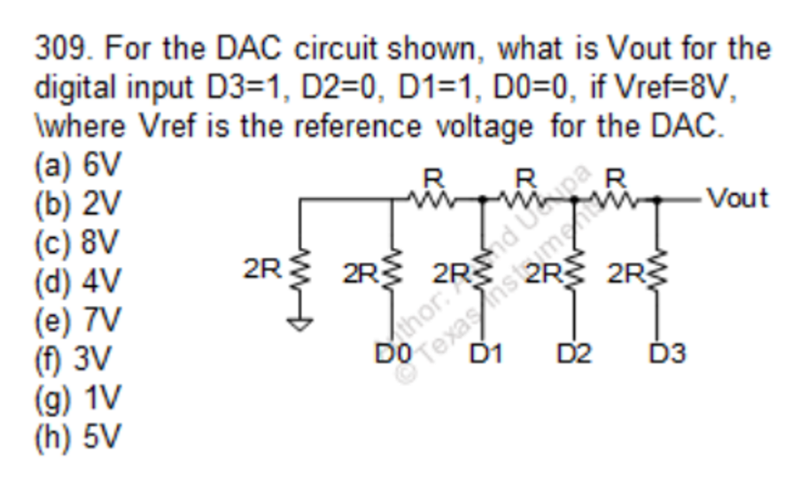

* + **QUCS Circuit:**

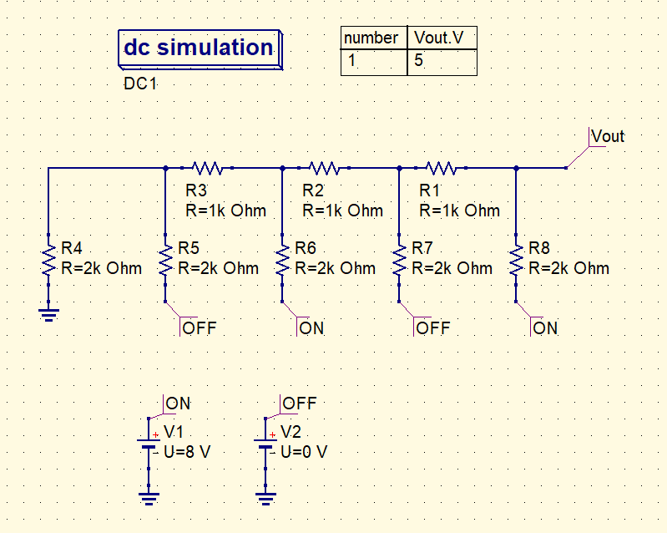

* **The node Vout is used to find out the resulting voltage at that node.**
* **The nodes ON is used to signify a Digital value of 1 (Analog equivalent voltage of 8 V (Vref)).**
* **The nodes OFF is used to signify a Digital value of 0 (Analog equivalent voltage of 0 V (Ground)).**
* **QUCS Result:**

**Therefore, from the simulation, we get our answer as:**

**Vout = 5V**

**Answer: (h)**

* **Conclusion:**
* **A Resistance-ladder can be minimized into a simple circuit using the Thevenin theorem or the Norton theorem.**
* **The superposition theorem can also be applied to simplify the complex ladder.**
* **A voltage source (V) and a resistor (R) in series can be converted into its Norton equivalent, a current source (I) and a resistance (R’) in parallel, by:**

$$I= \frac{V}{R} ;$$

**and, $R^{'}=R$**